Lab Environment
In this lab environment, you will be provided with GUI access to a Kali Linux machine. The target website is accessible at http://target.ine.local.
Objective: Identify web application vulnerabilities in the target website and capture all the flags hidden within the environment.
Useful wordlists:
/usr/share/wordlists/dirb/common.txt
/usr/share/seclists/Usernames/top-usernames-shortlist.txt
/root/Desktop/wordlists/100-common-passwords.txt
Flags to Capture:
- Flag 1: Sometimes, important files are hidden in plain sight. Check the root ('/') directory for a file named 'flag.txt' that might hold the key to the first flag.
- Flag 2: Explore the structure of the server's directories. Enumeration might reveal hidden treasures.
- Flag 3: The login form seems a bit weak. Trying out different combinations might just reveal the next flag.
- Flag 4: The login form behaves oddly with unexpected inputs. Think of injection techniques to access the 'admin' account and find the flag.
Solution:
Q.1 Sometimes, important files are hidden in plain sight. Check the root (‘/’) directory for a file named ‘flag.txt’ that might hold the key to the first flag.
Let’s begin by accessing the website in our browser. Since this is entirely web-based, running an Nmap scan is not necessary.

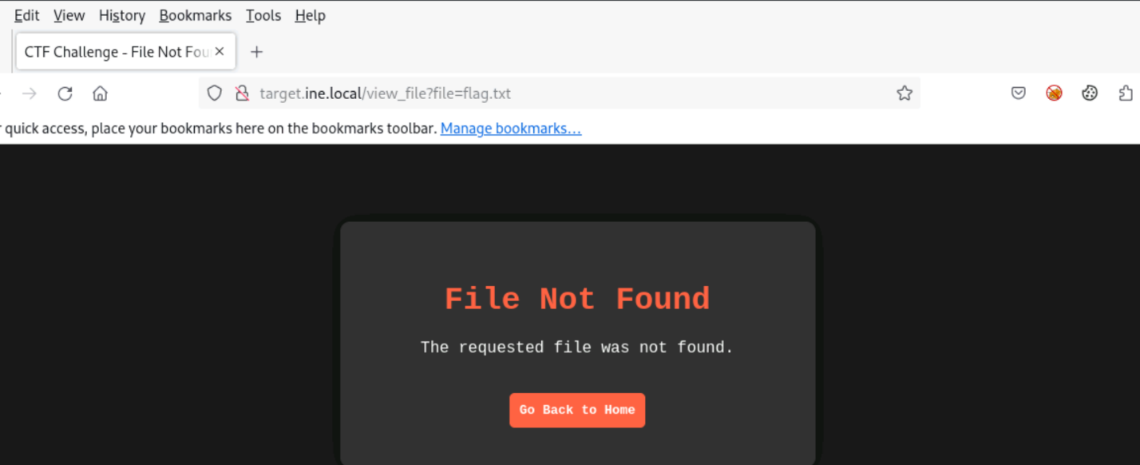

There is a “Select a File” functionality available. Let’s choose a file and view its contents.
Take a closer look at the URL: "http://target.ine.local/view_file?file=file1.txt". To locate the flag.txt file, modify file1.txt in the URL to flag.txt.
Since the question indicates that the file is located in the root directory, let’s attempt a Local File Inclusion (LFI) attack by modifying the parameter to ../../flag.txt. This successfully retrieves our first flag:

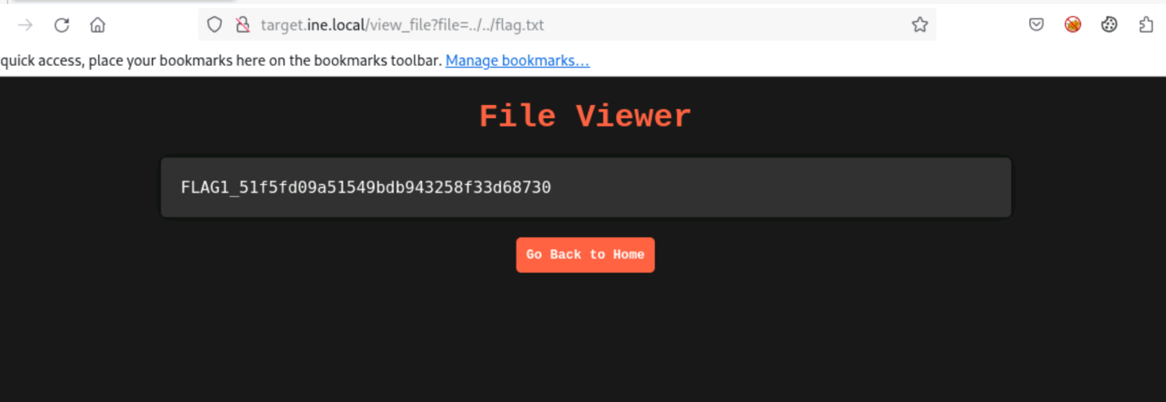
Flag:51f5fd09a51549bdb943258f33d68730
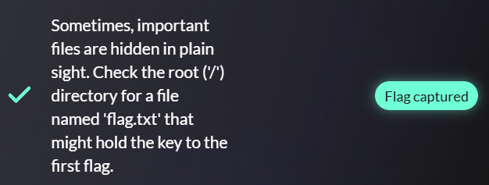

Q.2 Explore the structure of the server’s directories. Enumeration might reveal hidden treasures.
Do the directory enumeration with dirb:
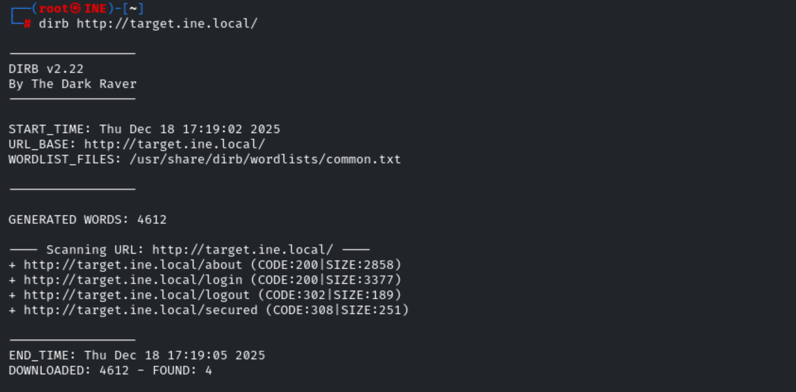
We discovered the endpoint /secured/. Let’s navigate to this endpoint in our browser to explore its contents.
Access it
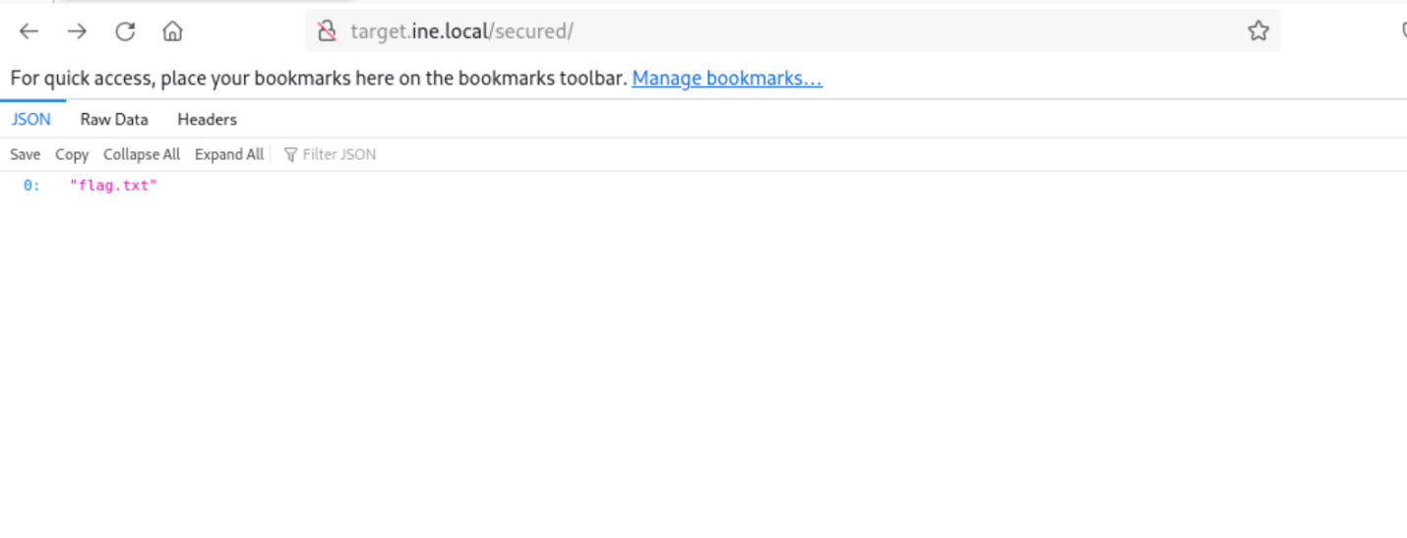
The /secured/ directory provides a direct location, so appending flag.txt to the URL http://target.ine.local/secured/flag.txt reveals our second flag which is:
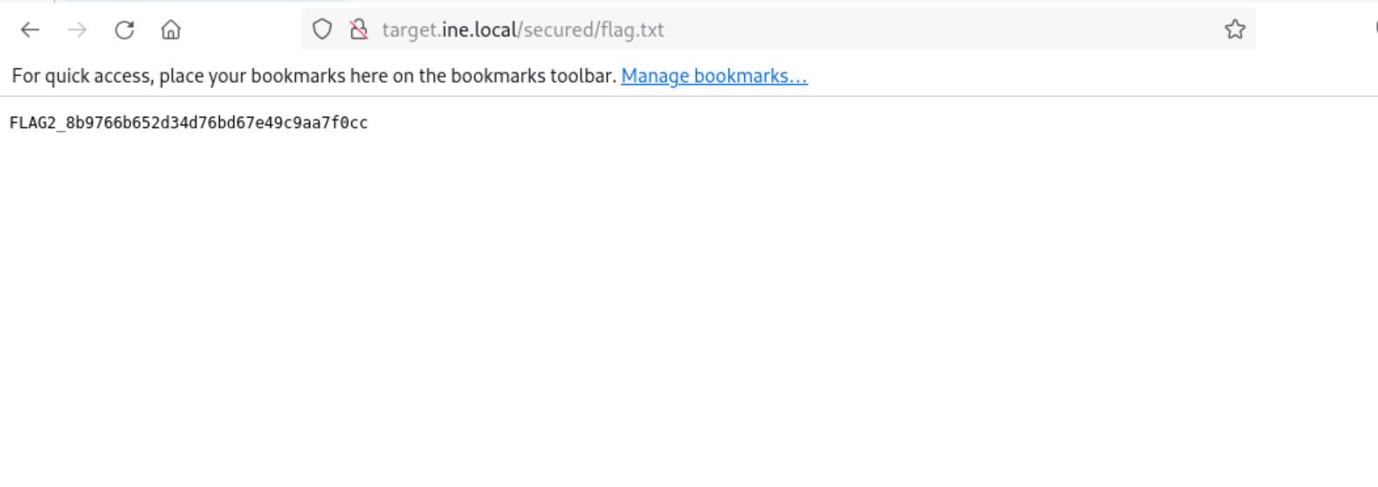
FLAG2_8b9766b652d34d76bd67e49c9aa7f0cc
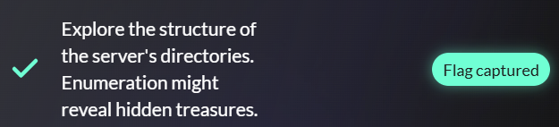

Q.3 The login form seems a bit weak. Trying out different combinations might just reveal the next flag.
Navigate to the login functionality by visiting http://target.ine.local/login.
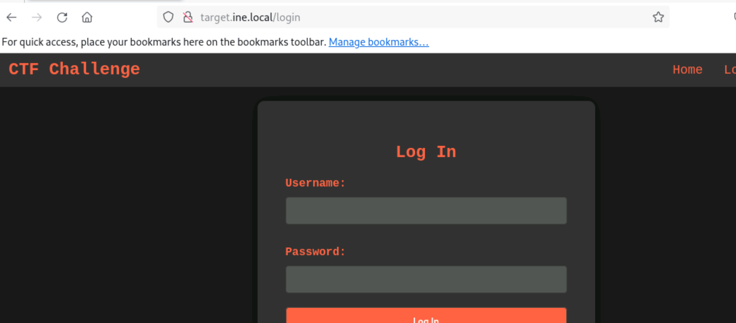

login functionality is weak, attempt brute-forcing using Hydra:

hydra -L /usr/share/seclists/Usernames/top-usernames-shortlist.txt -P /root/Desktop/wordlists/100-common-passwords.txt target.ine.local http-post-form "/login:username=^USER^&password=^PASS^:F=Invalid username or password"
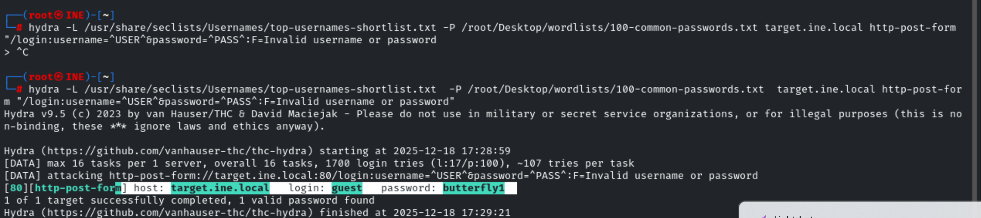

we have successfully obtained the credentials.
guest:butterfly1
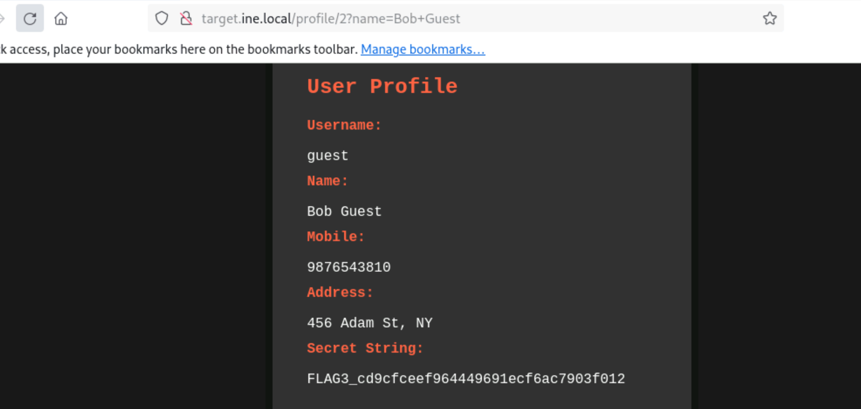

FLAG3_cd9cfceef964449691ecf6ac7903f012
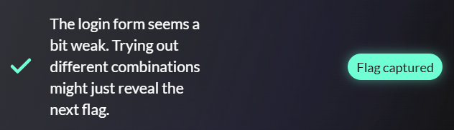

Q.4 The login form behaves oddly with unexpected inputs. Think of injection techniques to access the ‘admin’ account and find the flag.
SQL injection to gain access to the admin account. In the username field, enter admin'--, and in the password field, enter any random value. Since the SQL injection bypasses authentication, the password input will be ignored.

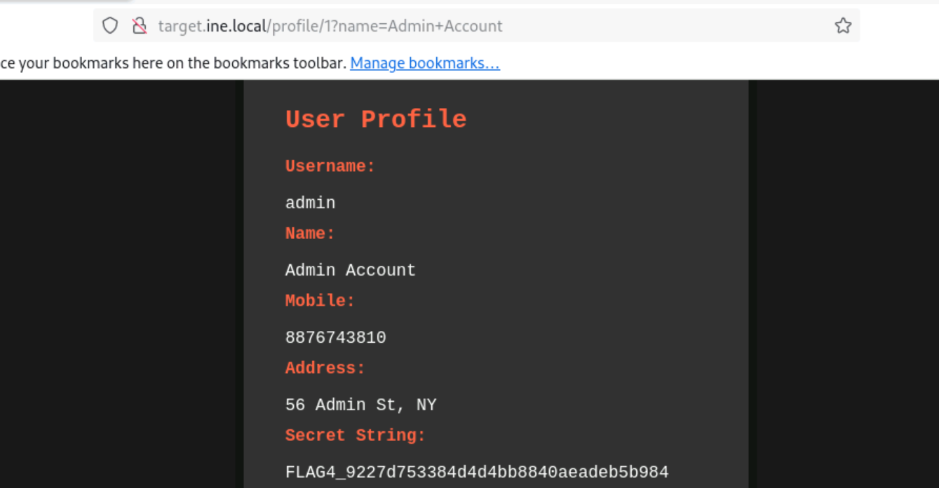

FLAG4_9227d753384d4d4bb8840aeadeb5b984

